Experiment 8.2
Determination and Plotting of Magnetic Flux Density vs Distance

Code File Name: Exp8_2_MagneticFluxDensity.m
Code
clc;
I = 5;
mu0 = 4*pi*1e-7;
r = linspace(0.1,10,100);
H = I./(2*pi*r);
B = mu0 * H;
plot(r,B,'LineWidth',2);
xlabel('Distance (m)');
ylabel('Magnetic Flux Density (T)');
title('Magnetic Flux Density vs Distance');
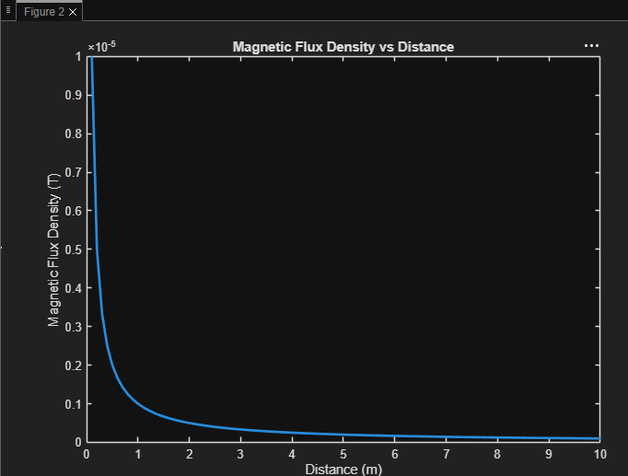
Output Graph

